Digital Asset Management (DAM) and Tasks Execution Guide

1. What is DAM and Why Do We Use It?

Digital Asset Management (DAM) is a system that allows organizations to store, manage, and distribute digital assets (such as images, videos, documents) efficiently. In Adobe Experience Manager (AEM), DAM is used to:

Organize and centralize digital assets.

Enable easy retrieval and reuse of assets.

Optimize asset delivery with renditions.

Ensure version control and access permissions.

2. Create a Folder and Upload Images in DAM

Steps:

Navigate to AEM > Assets > Files.

Create a new folder at the path: /content/dam/myTraining/us/en-us.

Upload two images inside this folder.

Open a page in AEM Sites.

Drag and drop the Image Component onto the page.

Select the uploaded images from DAM and author them into the component.

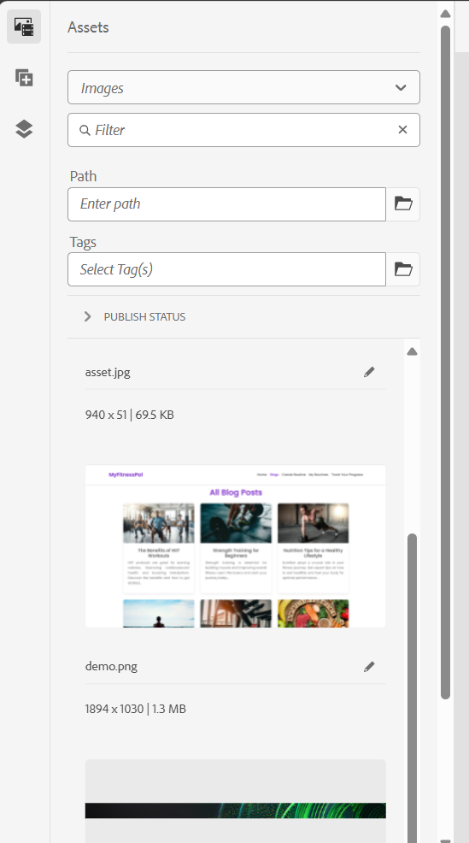

3. What Are Renditions?

Renditions are different versions of an image automatically created by AEM DAM. These variations help optimize asset delivery for different devices and use cases.

Steps to Check Renditions:

Navigate to AEM > Assets > Files.

Open one of the uploaded images.

Click on Renditions to view the different sizes available.

4. Add FirstName and LastName Fields in HelloWorld Component

Steps:

Open the HelloWorld component dialog in AEM Component Editor.

Add two fields:

First Name (firstName)

Last Name (lastName)

Modify helloworld.html to print these values using properties.

Example Code (helloworld.html):

<p>First Name: ${properties.firstName}</p>

<p>Last Name: ${properties.lastName}</p>

5. Use @ValueMapValue in HelloWorldModel

Modify the Sling model (HelloWorldModel.java) to use @ValueMapValue.

Example Code:

@Model(adaptables = Resource.class)

public class HelloWorldModel {

@ValueMapValue

private String firstName;

@ValueMapValue

private String lastName;

public String getFirstName() {

return firstName;

}

public String getLastName() {

return lastName;

}

}

6. Why Use Package Manager? (Creating Packages)

Package Manager is used to:

Export/import components and assets between AEM instances.

Ensure consistent deployment.

Backup assets and configurations.

Create Packages:

DAM Package (Images)

Go to AEM > Tools > Deployment > Package Manager.

Click Create Package.

Name it DAM-Images-Package.

Add the path: /content/dam/myTraining/us/en-us.

Build and download the package.

HelloWorld Component Package

Create another package named HelloWorld-Component-Package.

Add the path: /apps/myTraining/components/helloworld.

Build and download the package.

7. Configure Replication Agent and Publish Page

Steps:

Navigate to Replication Agents:

Go to AEM > Tools > Deployment > Replication.

Select Agents on Author.

Edit the default replication agent.

Set Transport URI to http://localhost:4503/bin/receive (assuming default setup).

Click Test Connection and Save.

Publish a Page:

Navigate to AEM > Sites.

Select the page and click Publish.

Command for Replication Test:

curl -u admin:admin -X POST http://localhost:4502/bin/replicate.json -d "path=/content/my-page&type=activate"

Final Note:

If issues arise, check logs in AEM Error.log (/crx-quickstart/logs)

For further debugging, use AEM Web Console (http://localhost:4502/system/console).

